**DOKUZ EYLUL UNIVERSITY**

**ENGINEERING FACULTY**

**DEPARTMENT OF COMPUTER ENGINEERING**

**CME1251 PROJECT BASED LEARNING – I**

**FINAL REPORT**

**PROJECT – I**

**Archery Game**

**by**

**ISLAM RAMAZANOV**

**YASAMIN VALISHARIATPANAHI**

**NİYAZİ EMRE AKBAŞ**

**KEREM KALINTAŞ**

**Lecturers**

**TANZER ONURGİL**

**Dr. Atakan KUBİLAY**

**IZMIR**

**21.10.2022**

# CHAPTER ONE

PROGRESS DESCRIPTION

In this code after we gave the variables, we uses the Console.WrireLine() to show what we want from the user and by Console.ReadLine() the user will write the entry. We need to control if the user has given the information that we need which is only integer numbers, if the user write the wrong entry other than the number with the Try.Parse() method, it will show the invalid entry in the console and the program will ended. We also need to control if the entry that the user has given us is between (-10,10) we move on with our code but if not it will show the user that it’s invalid and the program will end. Now that we control everything that we needed to randomly generate numbers between (-10,10) for B and C archers coordination’s by Random rand = new Random() function, of course we need to be careful about the range of it rand.Next(-10,11) it works like [-10,11). Now that we have the location of the three archers it’s now time for the randomly give the sets of shields and arrows to the archers. Again we need to use the Random() function, since there is 6 possibilities for these three archers we write it in the if else condition statement. Then we do the same thing for the randomly chosen health conditions. It would be also 6 possibilities for the if else condition statement. The we can show the status of the archers like the (coordinations, sets and healths) and the coordination system by Console.WriteLine().

We write the formula of the distances of any archers from one another, and with the help of the library Math we use the Abs() function of the manhattan_distance plus the maximum distance that within these distance the fight will happen. Now it’s time for the first fight to happen the round 1: in this part we need to find the closet distance of the archers for example; |AB| < |BC| and |AB| < |AC| with this condition we can understand that the archer A and B are the closest but if their distance are more that our maximum distance 15x15 the fight won’t will be happening otherwise we ca start our round 1: by two archer of A and B. Now we need to control the set options because having the special set can make you win the game. There would be two option I this situation if the A wins or if the B wins. If A wins that shows the set that randomly were given to the A was better than B, so in the fight A can defeat the B. with this concept the winner’s health would be reduced by 25 and the defeaters will be 0. The scoring part of course the defeater won’t gain anything but the winner will get 10 of the distance of these two archers plus the health of it after the fight (A_score += 10 * AB_manhattan_distance + (100 - A_health);) after this fight we show the conditions of the writer in the console. But if the B archer had the greater set, A was the one with the 0 health and B’s health’s would have been 25 reduced and gain score. Then just like this one we check the distances of B and C, C and A; then the possibility of winning the fight and we show the conditions in the console. Now that we have check all of the possibilities with the control statements, we show the result of the first round fight in the console and save the health’s of the archers by adding it with one another in the round 1 because we are going to need it later. Now we can begin with the round 2: the concept is that the winner of the last round will fight with the other archer and the game will be over by showing who has gotten the highest score. We can easily control it by if else control statements with who’s health is 0, that means that archers have been defeated and the two other archers can fight together. As the process is like the round 1 there would be no need to explain it by the example. First we have to check the distance of the other two archers. This time we control if their distance is less than the maximum distance, if it’s like this the fight begins with controlling that who has the winning sets and after that the winner will have the score and the health will be reduced by 25. The defeated one’s health will be 0 and gaining no score in this round. After controlling the conditions one by one we save the new health conditions in a variable by adding all of them together. Now if the old health conditions addition are greater than the new health conditions we show the status of the archers in the round 2 otherwise that won’t be needed and we just show the user that there was no attacking in this round of the game. Now it’s time to show that who has the high score in this game. Yet again we use the if else control statements by controlling that if A has the most score or not (A_score > B_score && A_score > C_score) if it is like that the A archer has the maximum score if it not like that it’s like (B_score > A_score && B_score > C_score) then the B archer has the maximum score if none of the above the C archer has the most score in this game. Now we also added some additional like changing the color of the archers in the beginning of the game. If the archer is defeated the color will be red, if the archer has survived and don’t attacked at all it will be green. We doing that by using the property of the Console, ForegroundColor we save the old color by using Console.ForegroundColor and then we control with if else that which archer’s health is 0, if it is the in the console and in our coordinate system it will show (Console.ForegroundColor = ConsoleColor.Red;) the color of that archer is red otherwise (Console.ForegroundColor = ConsoleColor.Green;) the color will be green.

After controlling each one of the one by one we need to set our archers in our coordination system by using SetCursorPosition(,) function and put them in the right location. We can doing it for the first parameter of this function “the columns positions” numbered from left to right and it starts at 0 and for the second parameter of this function “the rows positions” numbered from top to bottom and it starts at 0.

Then we print the archers location. We doing it for every archers one by one. After all of the above. We set our cursor to its previous location for the second parameter by counting the characters from top to bottom so our cursor will be in the next new line. In our project Console.SetCursorPosition(0, 46); our cursor came down 46 character down to the new location. By Console.ReadLine(); at the end of our program the console stays so we can see the result in it, until we click anything then the console will closes.

# CHAPTER TWO

TASK SUMMARY

## Completed Tasks

ISLAM RAMAZANOV

When i saw a project for the first time, i was a little scared cause i didnt know anything in c#, but after finishing some courses i realized how easy was it. And started to write a project. So i started with a cordinate system and was writing it by using a loops but then i found out that it was forbbidden and found easier way to write it. Then we started to write the conditions and that was the easiest part of the work cause we were just coping and pasting everthing with a little difference. And i wrote how to control the positions of players on the coordinate system.

YASAMIN VALISHARIATPANAHI

Well at the meantime that i draw the flowchart of the game i study to learn C# so i can understand the syntax that has been used. By the help of my teammate i learned that we can also change the colors and even the fonts in the console. Writing the second round of the code was a bit challanging and after i wrote it, with the help of my teammates i understood my mistakes and that helped me to learn C# much better. I realized that having a good teammates wasn’t bad afterall. Looking at other teammates i really liked that in our group all of us do this project together and we learned so much from each other, not just giving tasks to the other person or just someone do the whole project without even others knowing what have even happend.

NİYAZİ EMRE AKBAŞ

I gathered some information about the flowchart and I did draft of it and we discuss about how can we improve our flowchart with my project friends. In code part i wrote my own code but then i realized that i did some mistakes about the code. I searched them on google and asked my project friends to how can i fix those problems. I compare my codes with friend’s codes by my project friends and i did a little things to make the code look more better and some debugging with them. In presentation part we did work-sharing again. I take the poster part of it. It’s a little challenging because i have to do a good looking and explanatory poster. Lastly we did a good work and learned so much in this project.

KEREM KALINTAŞ

I did a reaserch about coloring the console characters. I wrote the condition statments and calculating scores. I created a variable for checking if there is been a attack in the round 2 of the game. I helped with the flowchart and corrected some mistakes. I wrote the code for printing status of archers after round 2.

## Incomplete Tasks: Reasons and Explanations

We have done everything, there is nothing left to do.

## Additional Improvements to the Project

After doing the main Project, we decided to add some additional to the Project.

Firstly if the user has entered the data that it’s not numeric and maybe it’s alphabetic or even some characters the program should warn the user, that what you are giving is a wrong input. By this idea we have searched in the internet, that how can we do this without using the loop statements. There is a method * TryParse(String, Int32) * in this method the program will check the input and sees if it’s a valid input or not. If it is the program will continue by reading other codes but if it’s not it will show a error in the console. As i mention later in the function section for this method; it converts the string input that it represent a number to a 32-bit signed integer then the return value will determine that this conversion is valid or not.

Secondly we decided to show the user that by the end of the game which characters are survived or a non fighter and which character is defeated. By changing their color to the green and red. Although we have wrote who has survived, didnt fight or defeated in the status of the archers but showing it in the console would be kind of user friendly and you can even understand by simply looking at the colors. We have used the property of the Console by changing the forground of connsole with Console.ForegroundColor and with the ConsoleColor.--- we can change the color of the character to what ever color that we want. In this example we used green and red.

# CHAPTER THREE

EXPLANATION of algorıthms

## Screenshot

This is the result of our code in the console.

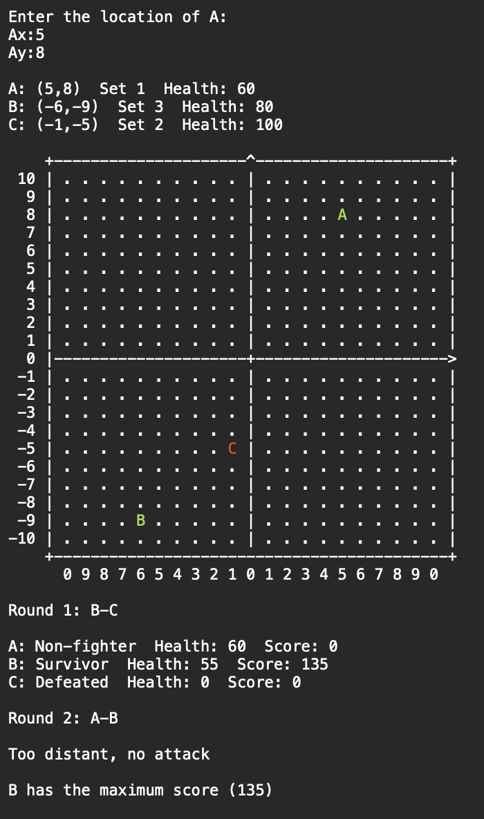

## Functions

TryParse(String, Int32) :

”TryParse is .NET C# method that allows you to try and parse a string into a specified type. It returns a boolean value indicating whether the conversion was successful or not. If conversion succeeded, the method will return true and the converted value will be assigned to the output parameter. If conversion failed, the return value will be false and the output parameter will not change value (default value).”

We have use this method to check the validation of our input value from the user, that if the user entered number for coordination or not. This method converts the string that reprresents a number to 32-bit signed integer. Then the return value will indicates whether this conversion is successfull or not.

Random ---= new Random();

--- = ---.Next(…, …);

With this function we can randomly generate number between [-10,10]. So we can place archer B and C. Of course we need to be careful with the range of the random function becasue for that range we should give the numbers like this (-10,11)

Write(), WriteLine(), Read(), ReadLine() : we have studied these functions in the class. We show the output in the console by the first two and the for showing the next output in the next line we use the WriteLine() function. For the second two we use it to take input from the user. And just like the other two functions, when we want to write the entry in the next line not just right after it we use the ReadLine() function.

We have use the Abs() function from the Math library. For calculatinng the distance of the archers from one another.

SetCursorPosition (int left, int top); :

With this function we manage to put the archer in our written coordinate sistem. It works like this : left one is the column position of the cursor and the number starts at 0 from left to right. Right one is the row position of the cursor and the number starts at 0 from top to bottom. We count every character in the coordination that we used plus we make the coordinatation bigger by putting 2 spaces in it so we multiply the given x in x-axis by 2 and addig it with the counted characters from the left. Also doing it with the y in y-axis count the characters from top and minus it with the give y.

We have also used a property of Console for changing the forground of console.

Console.ForegroundColor and with the ConsoleColor.--- we can change it to the color that we want.

## Algorithms and Solution Strategies

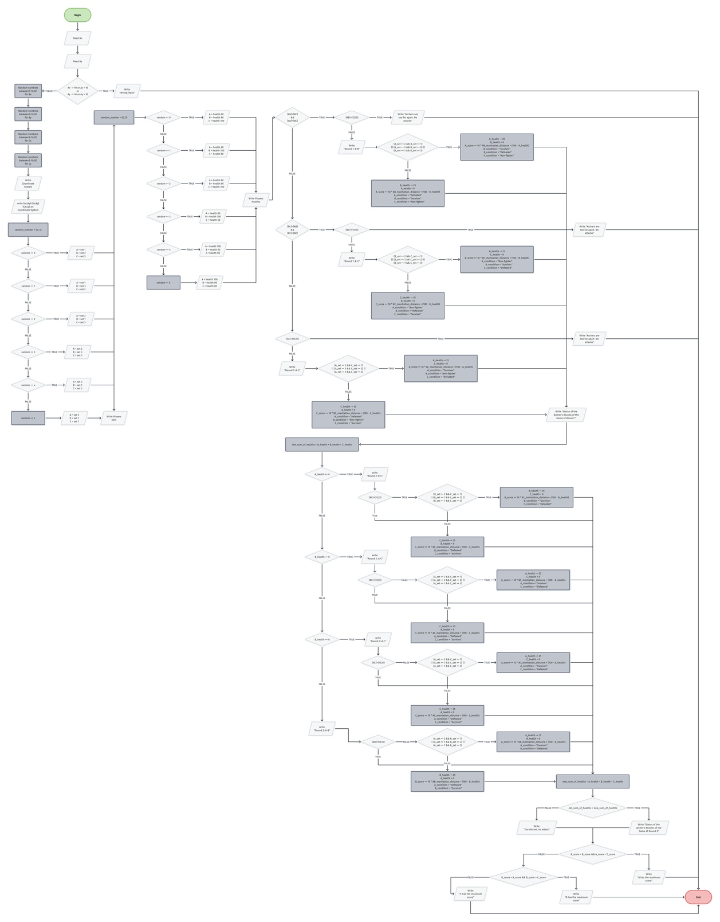

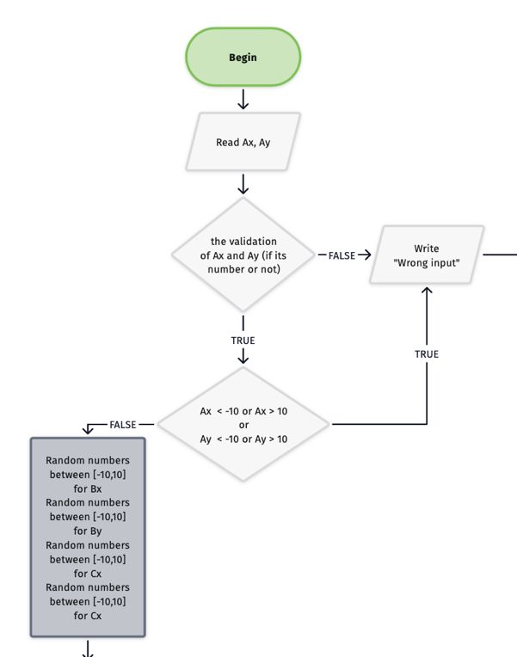  
-Algorithm of controling the validation of entry by the user.

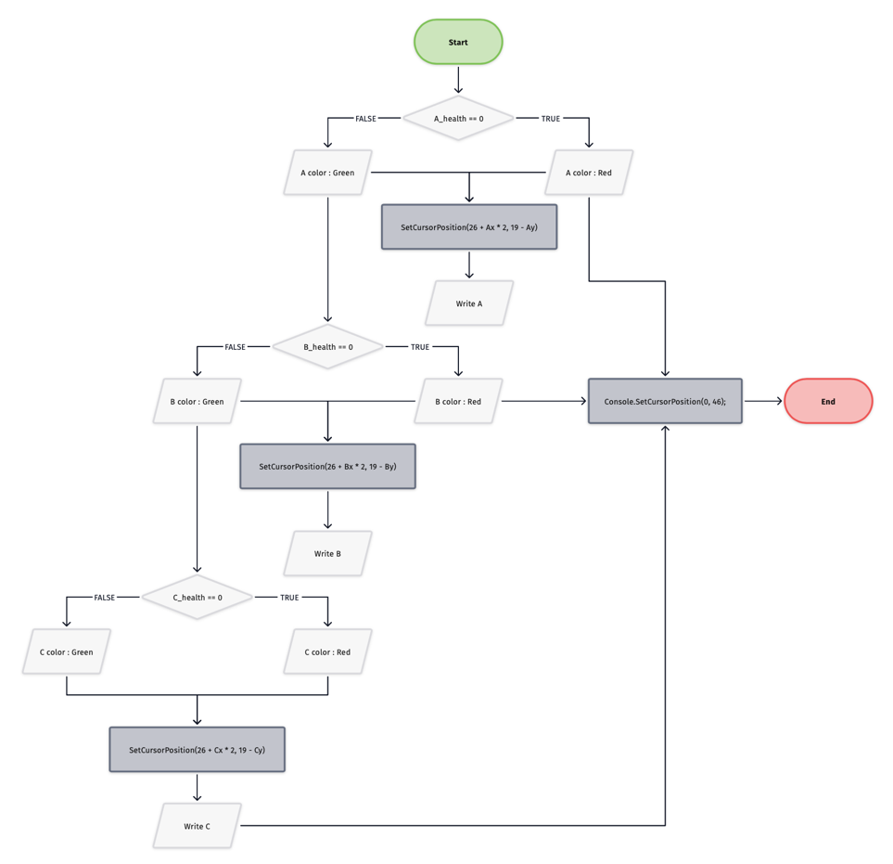

-Algorithm of changing the color of the archers after the game.

ISLAM RAMAZANOV

I was writing the code basing on my python knowledge but I didn’t help me a lot, cause I was working as a data scientist, and didn’t have any practice at game development. But when we draw a block-diagram I understood the requirements and implemented the assigned tasks.

YASAMIN VALISHARIATPANAHI

Drawing the flowchart while writing the code of this game was really helpful to understand where are we in writing our code. We had to used many if’s to write this code and drawing it for the flowchart, so the thing that made it kind of easier to read was understanding the what do we need and check the conditions by && and || that we learned so we can control the options at the same time not one by one that would have been confusing.

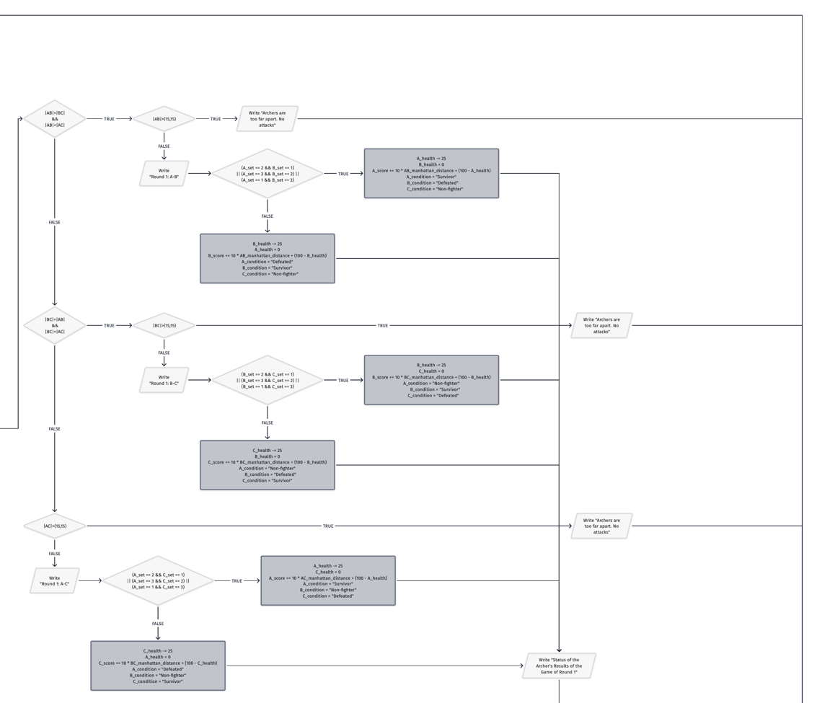

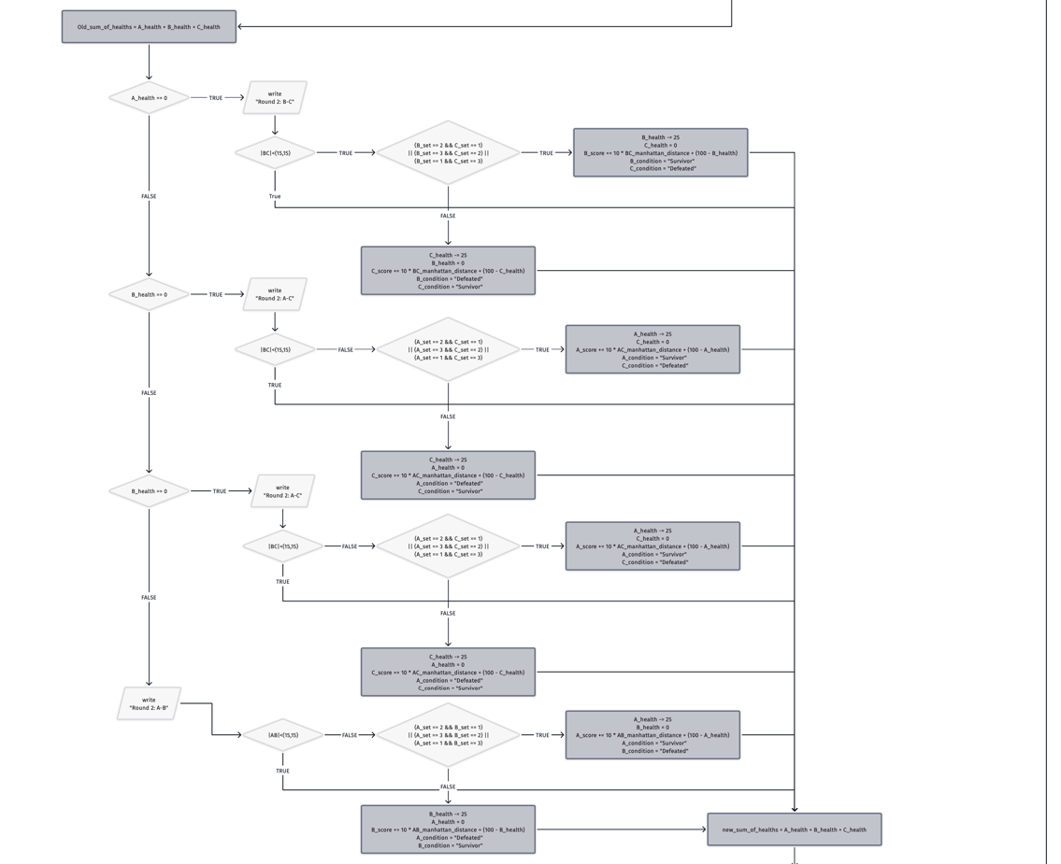

NİYAZİ EMRE AKBAŞ

This was my first C# experience so firstly I learned beginning of C# Then i made a first draft of my code. Later i saw my project friends went well and I learned them too much (randomly giving set situation, if and else operators etc.) and I added to my code them. Lastly I finish my code and gave some opinion to others and we finished our project. In presentation part we did work-sharing again. I took poster part and I did it carefully because I want to do both descriptive and good looking.

KEREM KALINTAŞ

I used an if else chain at the end of round 2 for deciding which player has the maximum score. After that we check every players healths and decide who defeated and who survived. Survived players are rendered as green and defeated players are rendered as red. We store previous text color of the console and change it according to players status. After rendering players we make the text color normal again.

# CHAPTER FOUR

PROBLEMS ENCOUNTERED

ISLAM RAMAZANOV

The main problem was when we finished the project and i accidantly noticed that the width of coordinate system was too small, then we talked to each other and fixed a problem.My personal problem was in not-knowing c#, but fortunatly i learnt it so fast and it was not a problem anymore.

YASAMIN VALISHARIATPANAHI

Working in the team was a challange for me. Although its not easy but i even learned new things while writing the code by my teammate. Definetly the presentation will be a challange for me. I am kind of a shy person and as i remember talking in the public was not my strongest suit. I hope i can overcome this fear of public speach by these presentations over time.

NİYAZİ EMRE AKBAŞ

Early in the project i didn’t know C# well. I overcome this problem by studying. So I improved my C# knowledge and i finished game. After the finishing game I found a problem if set 1 and set 3 fighting with each other set 3 winning fight because 3 numerically greather than 1 so I decide I shouldnt compare with numbers then I wrote situations one by one and solved the problem.

KEREM KALINTAŞ

My biggest challange was working with a team. But besides that project was fairly easy. The hardest part in this project was rendering the grid properly. We had to count every character in the grid to print players positions correctly.

# CHAPTER FIVE

conclusıon

By doing this project we understand how to work as a team, sharing information and helping one another to achieve a common goal like in this situation our project the archery game. Other than that we understand the if / else condition statement and how to use it properly. Managing our time and deliver a project before the deadline. Learning to present our written project to others that either have information or doesn’t have any. Also by doing this project we learned how to search our problems by googling in the internet and also seeing other peoples that have the same problem that we have encounter, learning new ideas or even making our own.

REFERENCES

* <https://www.lucidchart.com/pages/flowchart-symbols-meaning-explained>
* [https://app.diagrams.net](https://app.diagrams.net/)
* <https://en.wikipedia.org/wiki/Wikipedia>
* <https://www.geeksforgeeks.org/console-setcursorposition-method-in-c-sharp/>
* <https://learn.microsoft.com/enus/dotnet/api/system.console.setcursorposition?view=net-6.0>
* <https://www.pixilart.com>
* <https://www.canva.com>
* <https://josipmisko.com/posts/c-sharp-tryparse>

**AppendIx A**

Poster/Web page of the Project

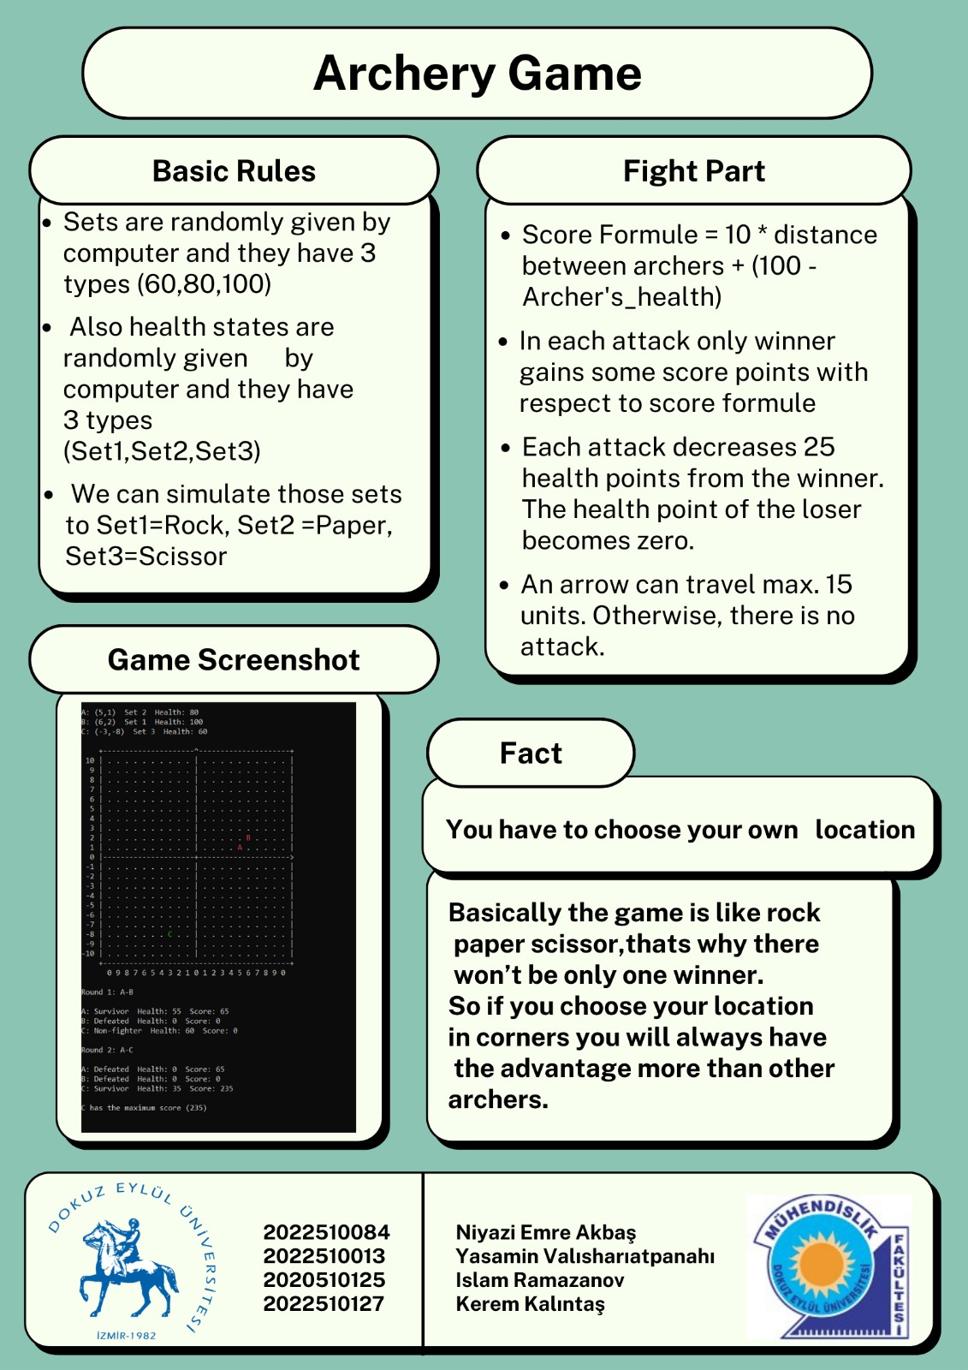

**AppendIx B**

Code of the Project

